**Computer Networks Lab Final Exam**

* **Name**: Shayan Adnan Hasan
* **Roll** **Number**: SE221060
* **Class**: SE-5B

**Question #1**

**Topology:**

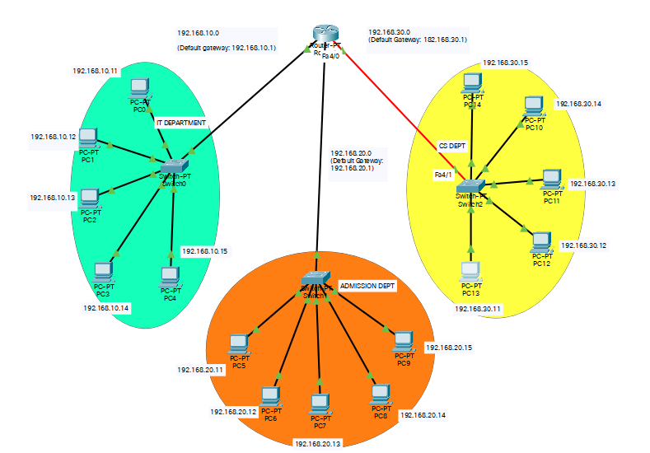

**Router Configuration:**

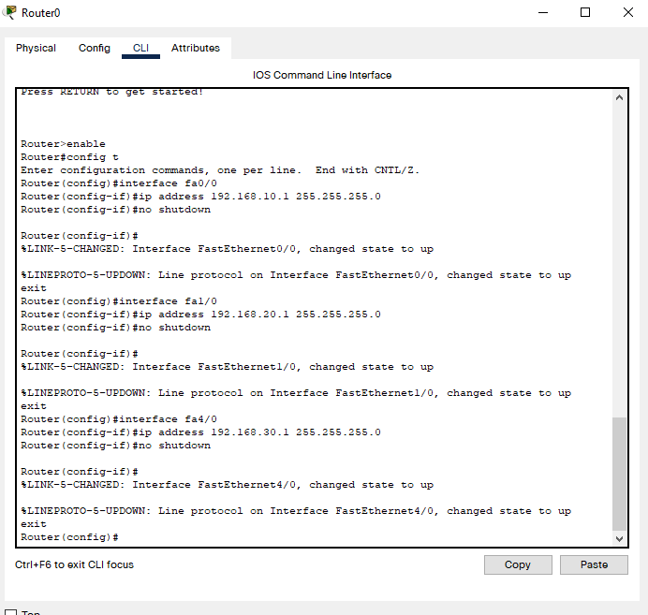

**Setting up DHCP (Router) to grant IPs automatically:**

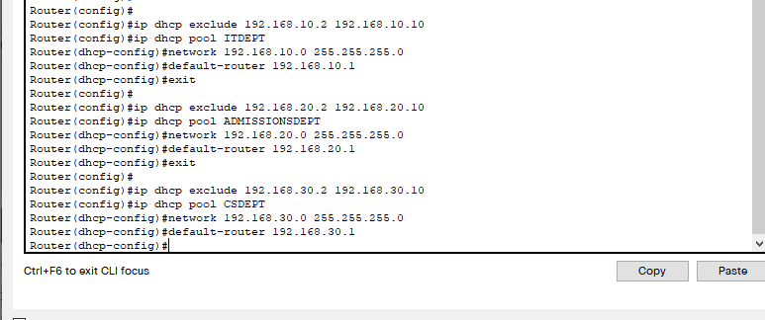

**PC Configuration:**

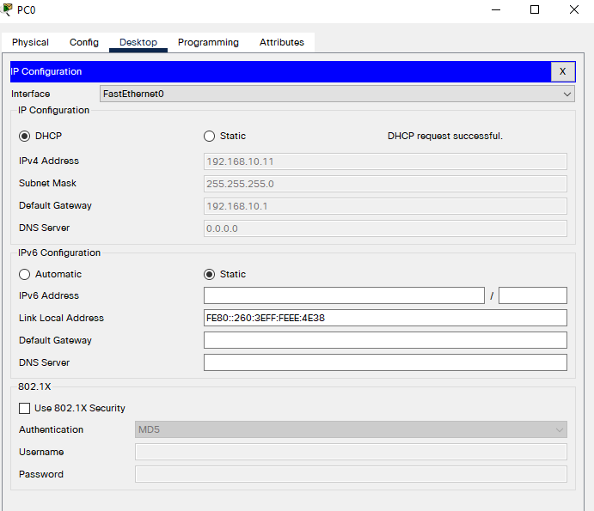

**Output:**

All five workstations of every department can successfully share data.

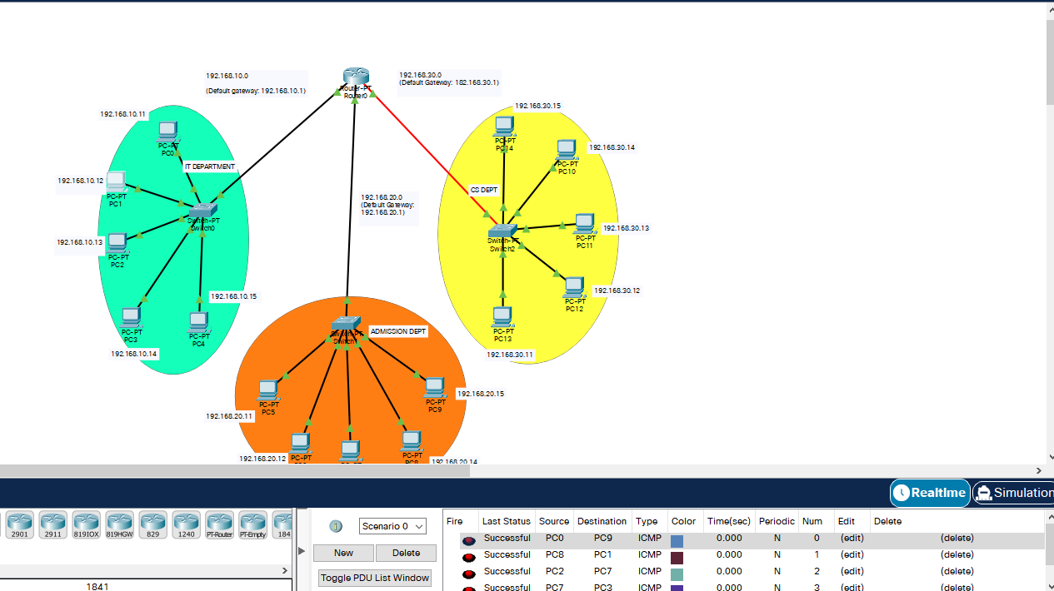

**Question #2**

**Topology:**

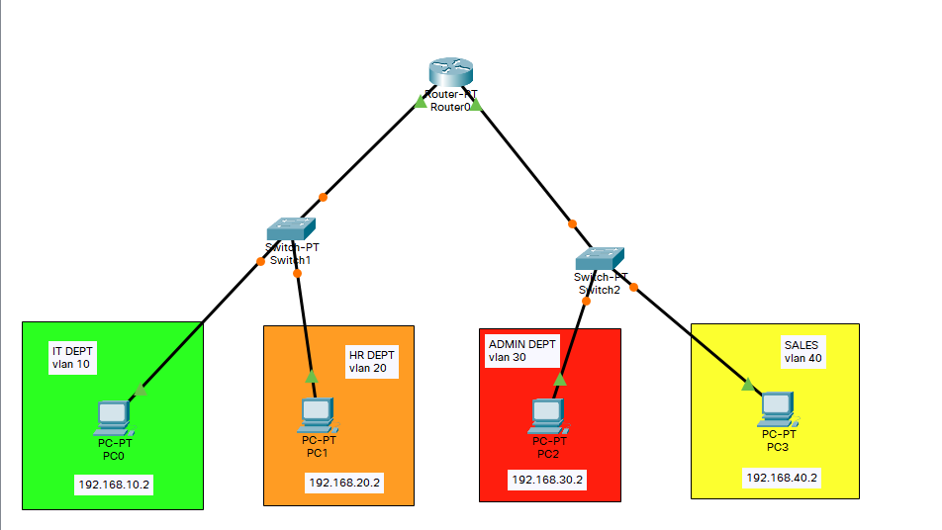

**Switch #1 Configuration:**

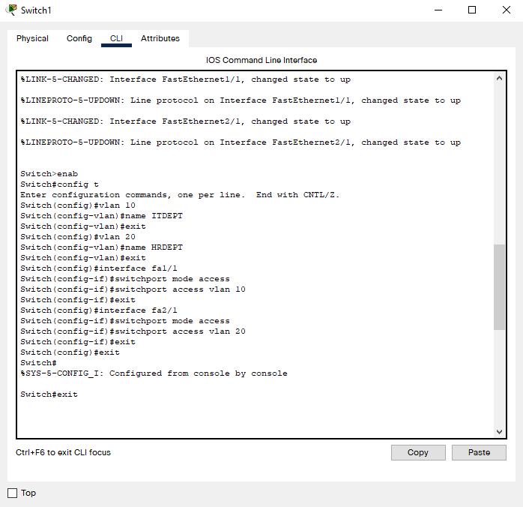

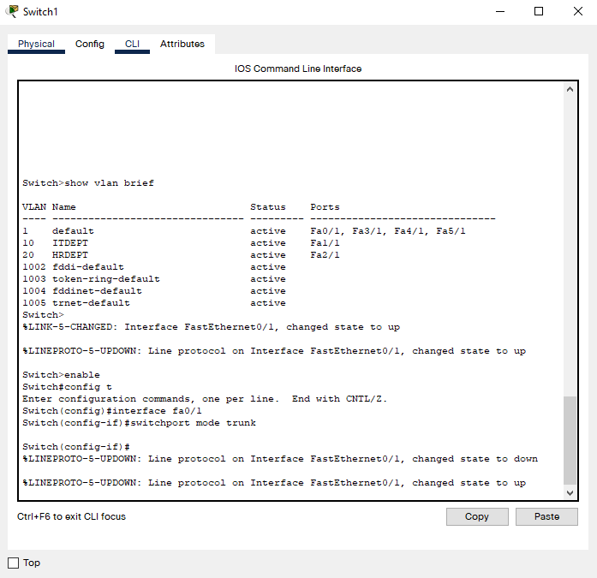

**Switch #2 Configuration:**

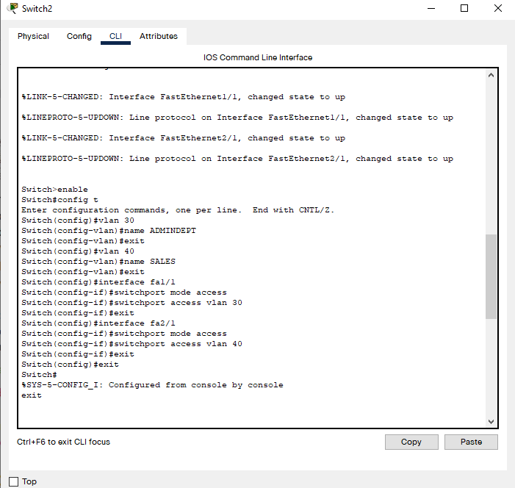

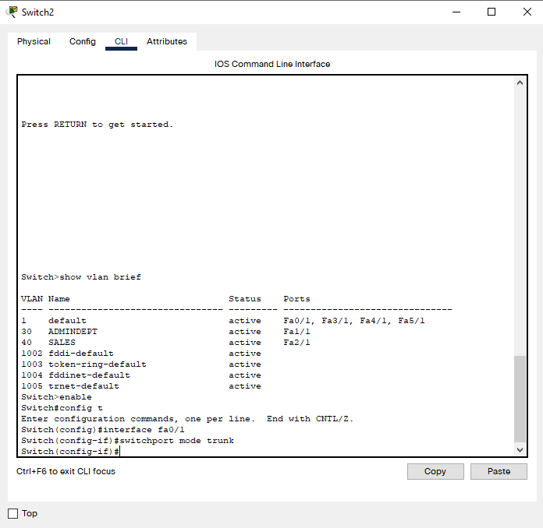

**Router Configuration:**

**For VLAN 10 and 20:**

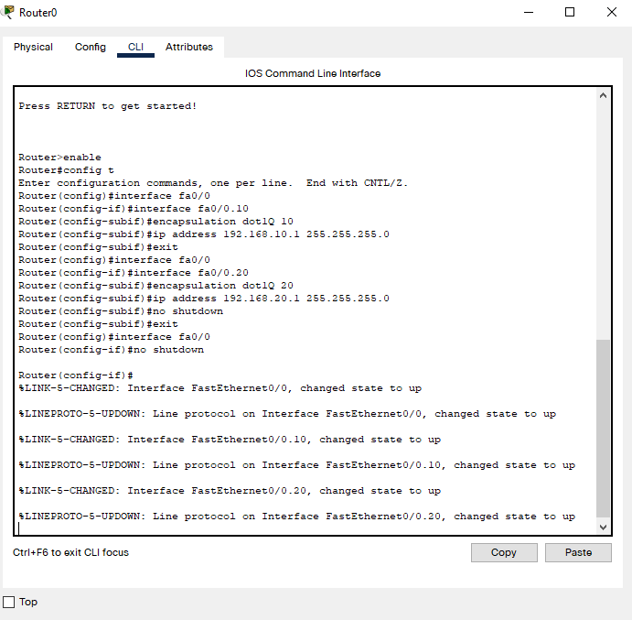

**For VLAN 30 and 40:**

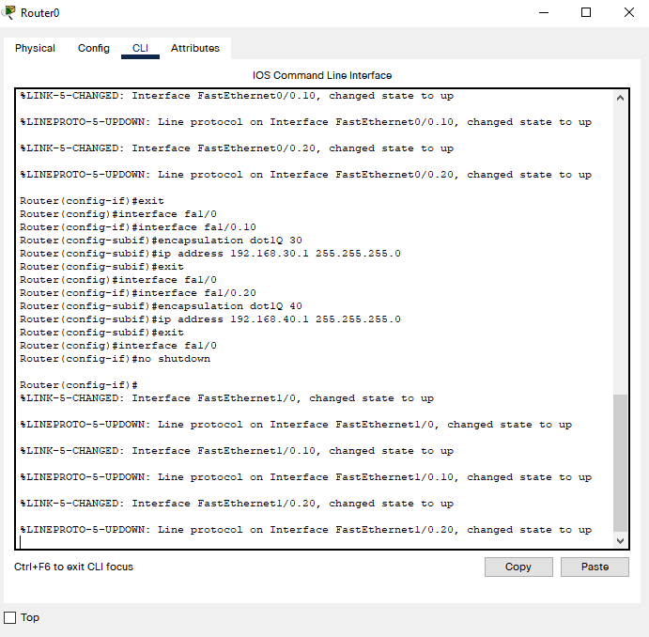

**PC Configuration:**

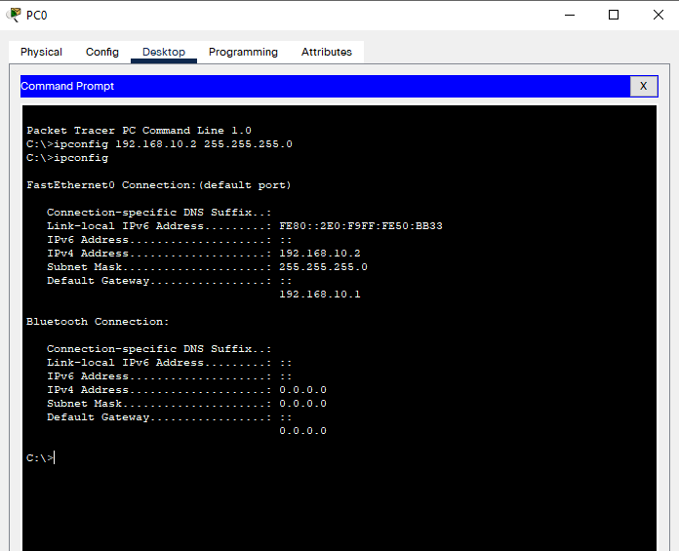

**Output:**

**All VLANs can successfully communicate with each other.**

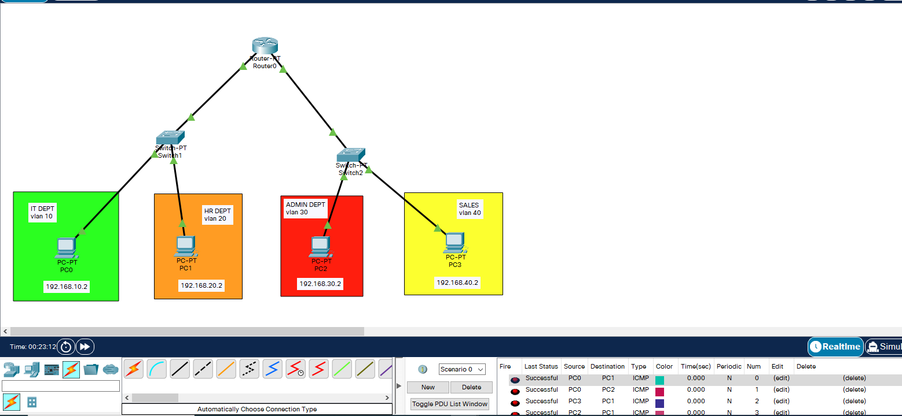

**Question #3**

**Topology:**

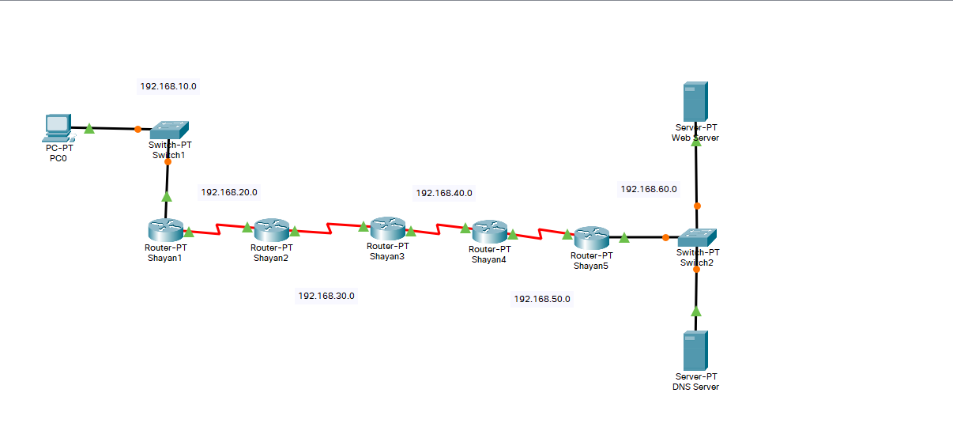

**Configuring IPs**

**Router #1 Configuration:**

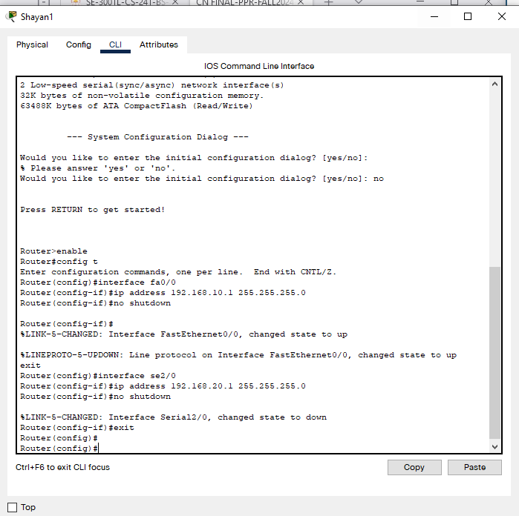

**Router #2 Configuration:**

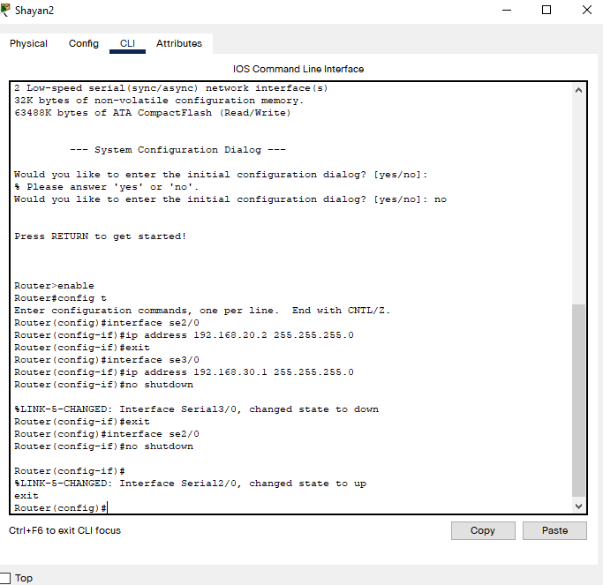

**Router #3 Configuration:**

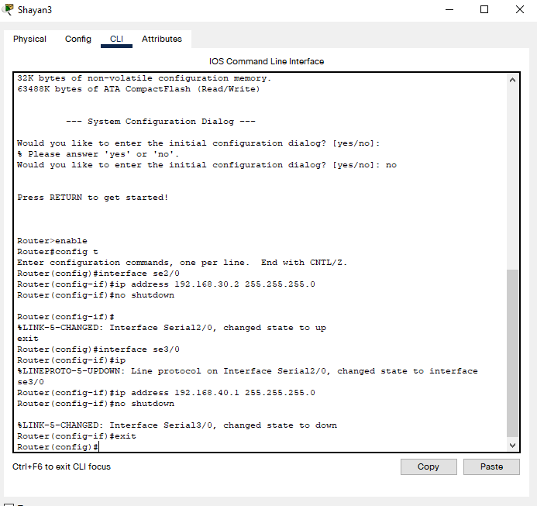

**Router #4 Configuration:**

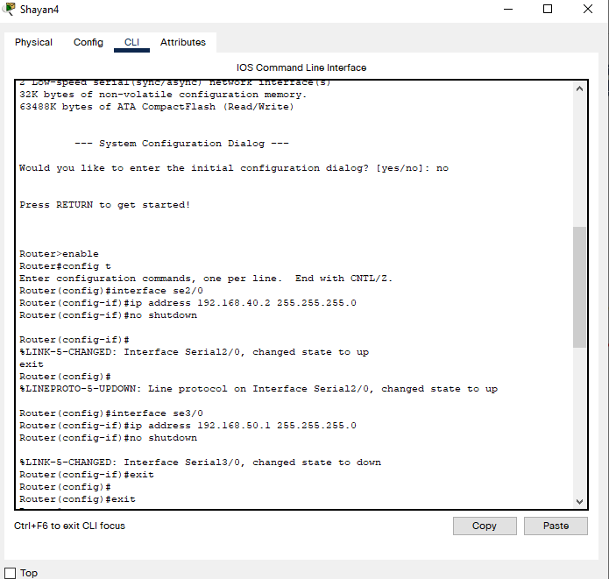

**Router #5 Configuration:**

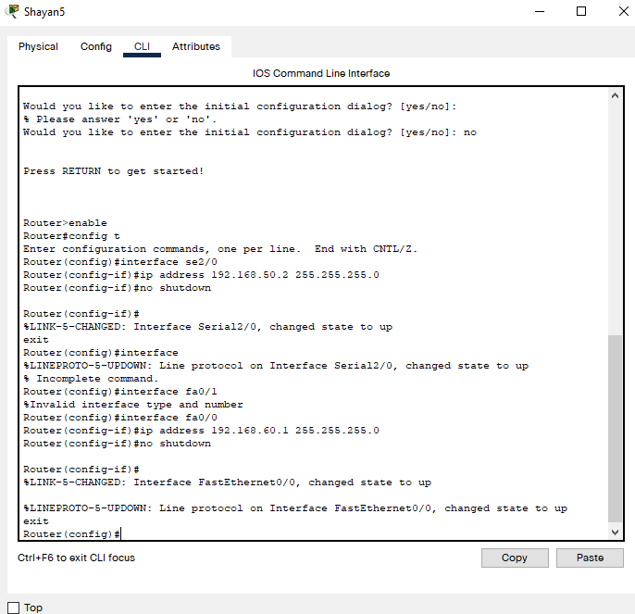

**Configuring Static Routes**

**Router #1 Configuration:**

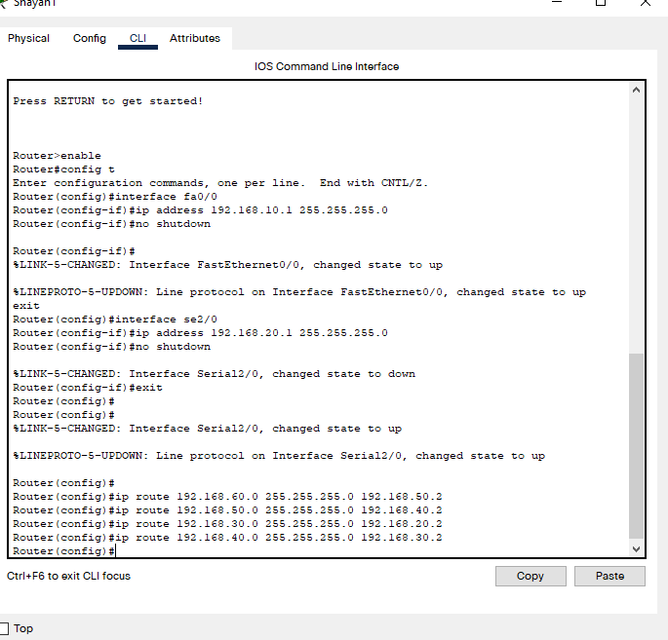

**Router #2 Configuration:**

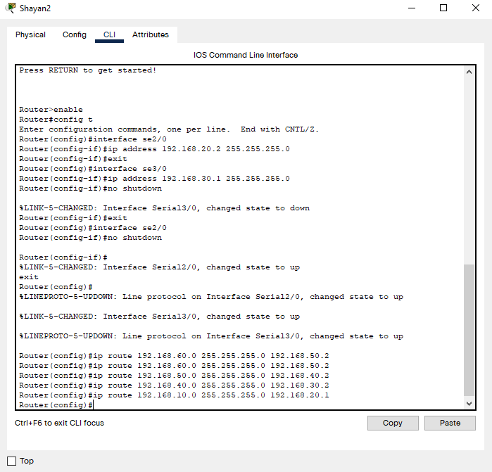

**Router #3 Configuration:**

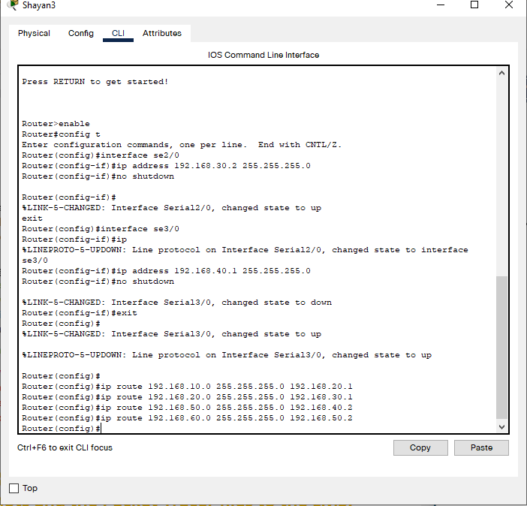

**Router #4 Configuration:**

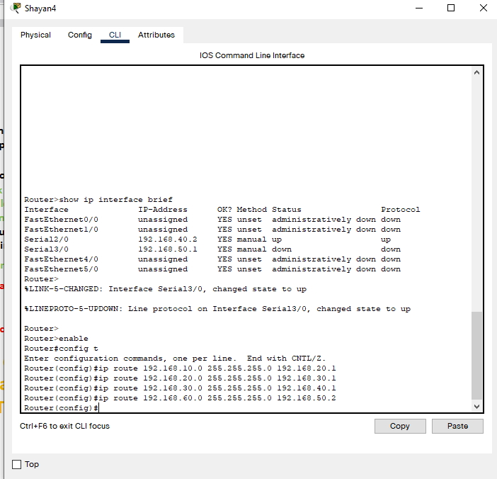

**Router #5 Configuration:**

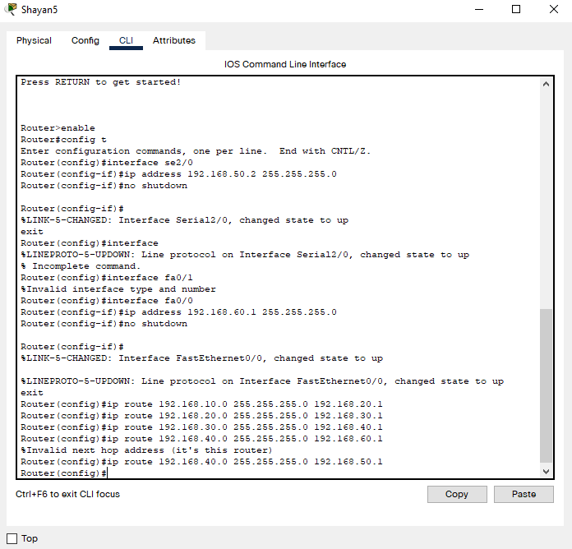

**Web Server Configuration:**

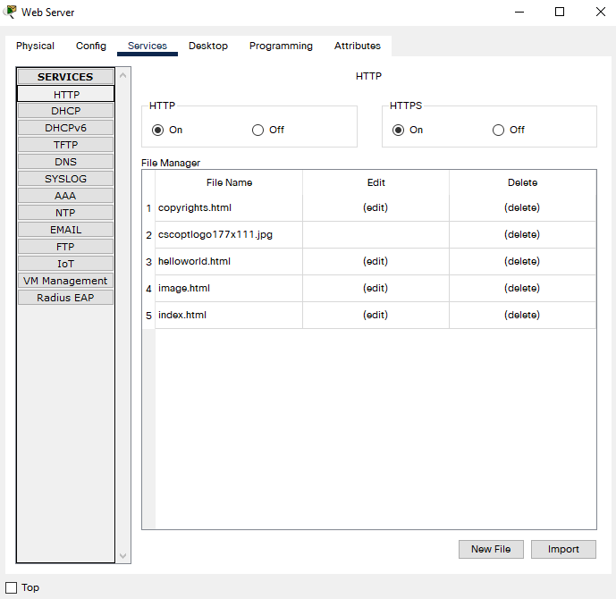

**DNS Server Configuration:**

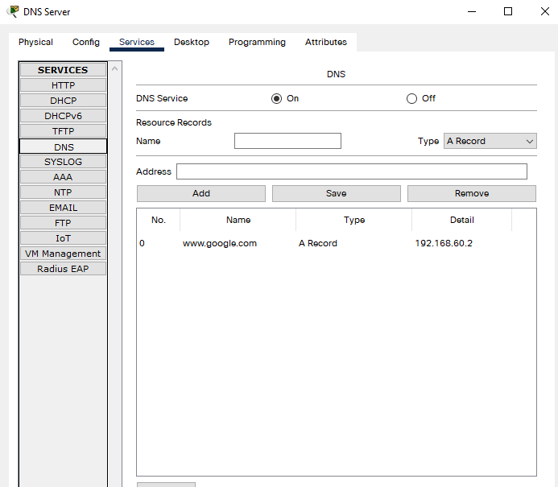

**Searching the Web using PC using Domain Name:**

